# Assembly language

# Using a PIC micro MCU with a 7-segment display to display 0 to 9 in each cell.

About: we will be using the PIC micro MCU type: 16F88 and a 7-segment display to show the numbers 0 to 9 in each cell for example:

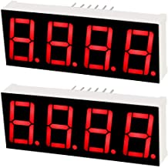

|  |  |  |  |
| --- | --- | --- | --- |
|  |  |  |  |

If the display had 4 cells like =>

|  |  |  |  |
| --- | --- | --- | --- |
| 0 | 0 | 0 | 0 |

It will start at =>

|  |  |  |  |
| --- | --- | --- | --- |
| 9 | 9 | 9 | 9 |

End at =>

We will use set Port B to output mode.

A short delay subroutine is called after each led on/off step

Assembler directives will be used

A "look up table " will be used to find the corresponding hex code for showing number X on the display.

To find out how the hex code was figured out use: <https://www.electronics-tutorials.ws/blog/7-segment-display-tutorial.html>